Classifying Alzheimer’s Disease Using Convolutional Neural Networks on Multi-Channel
 | EEG Data
Samrudhi Rao  CCBD&CDSAML  PES University  Bangalore, India  Raosamru@gmail.com | Sruthi Mahadevan  CCBD&CDSAML  PES University  Bangalore, India mahaiyer1967@gmail.com | Mahitha G  Assistant Professor  CCBD&CDSAML  PES University  Bangalore, India

Abstract—Alzheimer’s disease is a long-term illness characterized by a decline in abilities and the development of dementia. The main objective of this study is to explore the potential of using EEG-based classification for identifying and comprehending Alzheimer’s disease in its stages. EEG, which measures brain activity, offers insights into the functioning of neurons. This survey presents a thorough examination of feature extraction techniques, datasets, machine learning methods, and validation approaches used in Alzheimer’s disease detection. For our research, we used a dataset that included EEG recordings from individuals diagnosed with Alzheimer’s disease, mild cognitive impairment, and healthy individuals for comparison. EEG recordings from 19 channels were utilized as input features to investigate classification performance using a fine-tuned pretrained CEEDRestNet model. Additionally, 10 channels were extracted as features to be classified by a customized 1D ResNet18 convolutional neural network. To evaluate the effectiveness of these approaches, we assessed accuracy, sensitivity, specificity and precision metrics. The experimental framework was designed to test the capability of differentiating between Alzheimer’s patients and healthy individuals through neural signal analysis.
Index Terms—Deep Learning, Alzheimer’s Disease, Mild Cognitive Impairment, Early Diagnosis, Electroencephalography
I. INTRODUCTION
Alzheimer’s disease is a long-term condition that impacts the population across the globe, contributing to 60–80% of dementia cases that are diagnosed [2], [3]. It is characterized by the accumulation of tau tangles and beta-amyloid plaques in the brain which over time contribute to the loss of neurons and synapses, causing a deterioration in capacities [4], [5]. Typically, Alzheimer’s disease begins with disorientation and memory loss, which deteriorates into serious cognitive problems including language, cognitive, and executive function difficulties. Sadly, there is currently no treatment for Alzheimer’s. The existing treatments attempt to lessen symptoms and delay the illness’s progression.
Fig. 1 visually demonstrates how the number of deaths caused by Alzheimer’s disease has changed from 1999 to 2021. The data [6] offers information on these deaths over this time period. The figure clearly shows a trend in the number Mahithag@pes.edu
of deaths, with some fluctuations occurring over the years. Specifically, there was an increase in deaths, from 44,536 in 1999 to 134,242 in 2021. These statistics highlight the impact that Alzheimer’s disease has had on the population over the years. Addressing this growing burden necessitates efforts to understand, prevent, and treat Alzheimer’s disease for the benefit of affected individuals and their families.
The electroencephalogram (EEG) records the voltage variations resulting from the collective firing of neurons to quantify the electrical activity of the brain. It offers a clear, cheaper and non-invasive view into the neuronal dynamics and functioning of the brain. Since EEG can record the temporal dynamics and synchronization of brain activity, which are impacted by the degenerative processes of AD, it provides special advantages in this context. Research has uncovered distinctive EEG rhythms and irregularities seen in AD patients. These include changes in connection metrics like coherence and phase synchronization between various brain regions, as well as a decrease in alpha and theta band power and an increase in delta and beta band power [7]. In AD, connectivity between different brain regions is disrupted, and underlying neuronal dysfunction is reflected in these anomalies in the EEG [8].
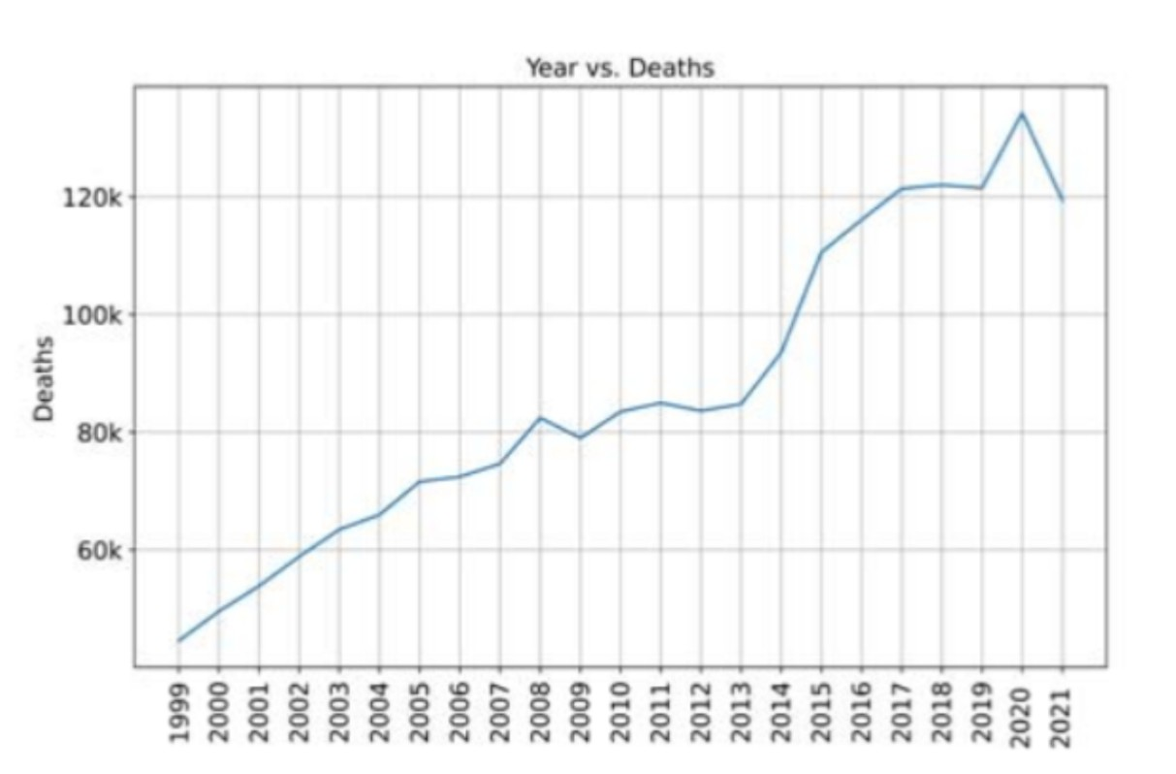
Fig. 1. Total deaths by Alzheimer’s disease
The aim of the research is to leverage the capabilities of EEG and machine learning to enhance the early detection and comprehension of AD.
II. METHODOLOGY
The process of diagnosing Alzheimer’s disease using EEG includes the following steps. First, the data is converted to CSV, then preprocessed by normalising and filtering it. Then, meaningful features are selected using mutual information correlation and then extracted. Finally, the custom model and the fine-tuned model are used for classification. To evaluate the performance of the classifier, metrics such as accuracy, precision, recall, and F1 score are considered. By following this approach, EEG signals can be effectively transformed into features that enable the diagnosis and classification of Alzheimer’s disease.

A. Dataset
The CAUEEG dataset [9] used contains 1379 EEG recording signals acquired from 1155 patients at Chung-Ang University Hospital from 24th August 2012 to 12th March 2020. EEG. The other two channels are electrocardiogram (EKG or ECG) and photic stimulation. The EEG recording was conducted according to the International 10-20 system (electrode locations: Fp1, F3, C3, P3, O1, Fp2, F4, C4, P4, O2, F7, T3, T5, F8, T4, T6, FZ, CZ, and PZ) with linked earlobe referencing. The EEG signals of subjects were measured while they were lying comfortably in bed but awake, and a qualified technician in the hospital supervised the recording process. The signals were then converted to the common average referencing and saved in European data format (EDF) on disks.
For each EEG recording, the CAUEEG dataset provides i) the event history that occurred while recording, ii) the patient’s age at the time, and iii) the corresponding diagnosis label decided by neurologists based on neuropsychological examination and criteria.

B. Preprocessing
To make the EEG data convenient to use, we have converted it to CSV files. Data from subjects with conditions other than AD were filtered out, and files were renamed with the class label as the first digit. For the custom model, 9 channels were ruled out, and each of the CSV files were brought down to a reduced dataset of 10 channels.
1) For the custom model: : To ensure consistency across recordings and facilitate model convergence, all EEG signals were subjected to a standardised preprocessing pipeline. From each raw EEG file, the first 10 channels were selected and transposed into a [channels × time] format. To handle variable-length recordings, signals exceeding 2000 time points were randomly cropped, while shorter ones were zero-padded to maintain a fixed input size. Finally, z-score normalisation was applied channel-wise to remove baseline shifts and scale differences. This preprocessing helped reduce noise and ensured that the model learned robust temporal patterns across
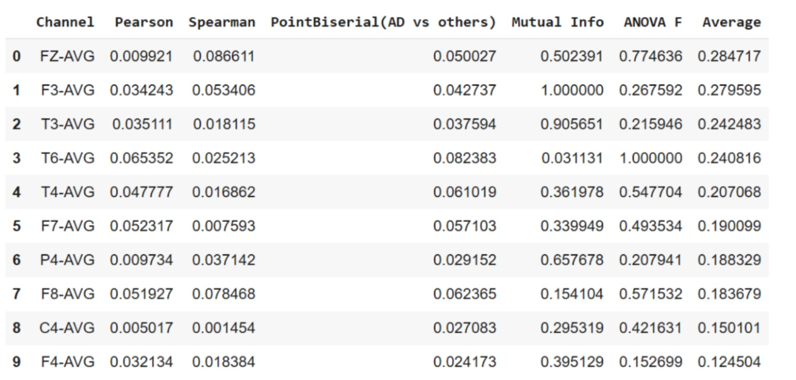
Fig. 2. Results from testing out different correlations graphically
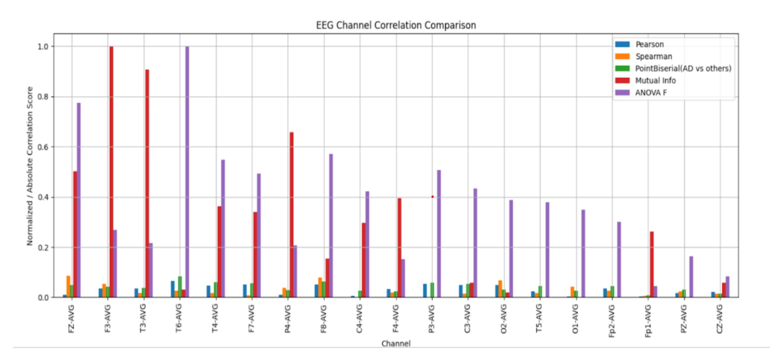
Fig. 3. Results from testing out different correlations and graphically
all subjects. Feature extraction of 10 channels was done by testing the data with Pearson, Spearman, Point Biserial, Mutual information and ANOVA F correlation functions, of which mutual information was deemed best fit for our data. The mutual information correlation calculates:
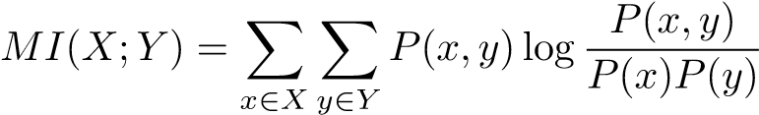 (1)
where P(X,Y) is the probability of EEG value x and label Y occurring together and P(X) and P(Y) are their independent probabilities.
2) For the fine-tuned pretrained RESNET-18 model: Each CSV file contained 22 channels comprising 19 EEG channels and 3 additional signals(EKG, Photic, and Time), recorded at a sampling frequency of 250 Hz. For each participant, 500sample epochs ( 2 seconds) were extracted and preprocessed as follows: A 5th-order zero-phase Butterworth bandpass filter [10] was applied to all 22 channels, including EEG, EKG, and photic signals, were independently bandpass filtered (1–40Hz) to reduce noise while preserving temporal dynamics. Although EKG and photic channels are not artifacts, they were filtered uniformly for consistency across inputs. Following filtering, the signal length was standardised to 500 time points across all samples by either truncation or zero-padding. For robust model performance, all signals were normalised using datasetspecific statistics with the help of a random subset of 100 training samples.
Specifically, the first 20 channels were normalised to zero mean [11] and unit variance using:
X˜i = Xi − µeeg (2) σ_{eeg} + ϵ
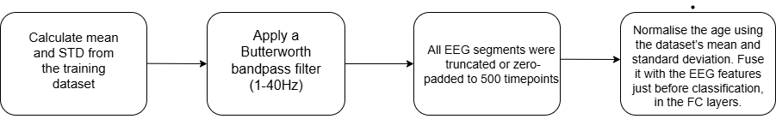
Fig. 4. Workflow of pre-processing for fine-tuned model
where µ_{eeg} and σ_{eeg} denote the mean and standard deviation of the EEG signals, respectively, and ϵ = 10⁻⁸ ensures numerical stability.
Similarly, the patient’s age was normalized as:
a − µ_{age}
a˜ = (3) σage
where µ_{age} and σ_{age} are computed from the training set. The preprocessed signals, paired with their corresponding normalised age values and diagnostic labels (Healthy Control, Mild Cognitive Impairment, Alzheimer’s Disease), were subsequently used for model training.

Model Architecture and training
- RestNET 1D Models: RestNET 1D Models are a specialised version of deep residual networks designed to work with one-dimensional sequential data, building on the core principles developed by He et al. for analysing signals that change over time. These networks use skip connections that allow information to flow directly through deep layers, solving a common problem where gradients become too small to effectively train very deep networks. The core building block applies stacked 1D convolutions with normalization and activation, adding the processed output back to the input via identity shortcuts (y = F(x) + x). This structure allows the model to capture temporal patterns at different scales while preserving overall sequence information. These features have made ResNet-1D a reliable choice for various applications, including time-series prediction, audio processing, and medical signal analysis, where understanding temporal patterns and maintaining computational efficiency are essential requirements.
- Custom RestNET Model: The proposed experimental framework employs a 1D ResNet-18 backbone architecture, which is investigated for its ability to capture temporal dependencies in EEG signals through one-dimensional convolutional layers and residual connections. The residual connections are designed to preserve identity mapping across layers, potentially enabling stable gradient flow during training. Each residual block is configured to output a combination of the transformed input F(x) and the original input x, mathematically expressed as:
y = F(x) + x (4)
To address the significant class imbalance present in the EEG dataset—where pathological classes such as MCI and AD are substantially underrepresented compared to healthy controls—a weighted training strategy is implemented as a necessary modification to the standard training procedure. Class weights are computed inversely proportional to class frequencies to examine whether rarer classes can achieve a larger impact on loss minimisation. The class weight for a class c is calculated as:
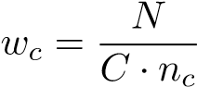 (5)
where N represents the total number of samples, C denotes the number of classes, and n_{c} indicates the number of samples in class c.
During the optimisation process, the Adam optimiser [12] is employed to investigate its effectiveness in adapting learning rates for each parameter using first and second moment
estimates of gradients. The parameter update rule for each is given by:
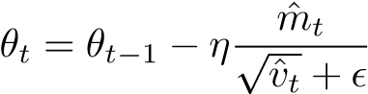 (6)
This experimental design, combining residual-based architecture, class-aware training, and adaptive optimisation is hypothesised to enable the model to learn robust representations of EEG patterns, even under conditions of noise and imbalanced distributions. The effectiveness of these methodological choices will be evaluated through comprehensive performance metrics.
3) Fine-Tuned Pretrained Model: The proposed framework employs a 1D ResNet backbone tailored specifically for the automated detection of dementia and its subtypes using EEG recordings. Leveraging a pretrained model facilitates the network’s ability to utilize knowledge acquired from large-scale EEG datasets associated with cognitive impairments. This improves generalization and accelerates convergence on the target dataset, which is relatively smaller.
The EEG signals are represented as one-dimensional sequences with 22 input channels comprising standard EEG leads, electrocardiogram (EKG), photic stimulation markers, and temporal markers. One-dimensional convolutional layers are applied along the temporal axis to capture time-varying neural dynamics. This architecture exploits the temporal structure inherent in EEG recordings while maintaining spatial (channel-wise) specificity, which is critical for interpreting disease-specific biomarkers.
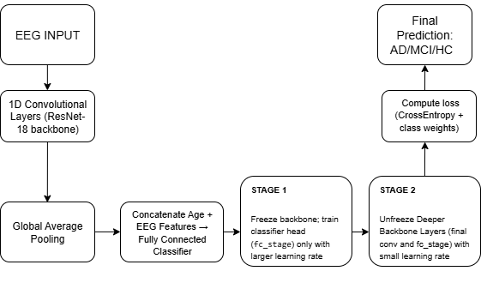
Fig. 5. Architecture of the fine-tuned ResNet-18 model
The dataset exhibits class imbalance, with Alzheimer’s Disease (AD) and Mild Cognitive Impairment (MCI) subjects underrepresented relative to Healthy Controls (HC). To address this, a weighted cross-entropy loss was used, where class weights w_{c} were computed as:
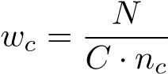 (7)
Here, N is the total number of samples, C is the number of classes, and n_{c} is the number of samples in class c. This weighting encourages the model to emphasize learning from minority classes, particularly AD, thereby improving classification robustness.
Training was performed using the Adam optimizer [12], which adaptively updates model parameters using first- and second-moment estimates of the gradients. The parameter update rule is:
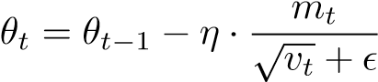 (8)
where m_{t} and v_{t} are the bias-corrected first and second moment estimates of the gradients, η is the learning rate, and ϵ is a small constant for numerical stability. A ReduceLROnPlateau scheduler [13] was used to reduce the learning rate when the validation loss plateaued, promoting convergence.
The feature extractor is based on a residual network composed of four convolutional stages with the following configuration:
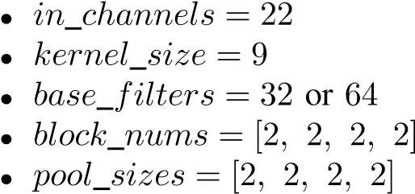
Each residual block consists of stacked 1D convolutions with batch normalization and ReLU activation, followed by identity shortcuts to implement residual learning. The structure is defined as:
y = F(x) + x (9)
This design facilitates deeper architectures by preserving information flow and enabling efficient gradient propagation.
The output of the final convolutional stage is flattened and concatenated with a normalized scalar age input. This combined representation is passed through a fully connected classifier with the following structure:
- Fully connected layers: 512 → 256 → 128 → 3
- ReLU activation between layers
- Output: 3 logits corresponding to HC, MCI, and AD
Incorporating age at the classifier level enables the model to account for age-related variability in EEG, which is important for differentiating stages of dementia.
To effectively adapt the pretrained model, a two-stage finetuning strategy was employed. In the first stage, only the classifier head (fc_stage) was updated, while the convolutional backbone layers (conv_stage1 through conv_stage4) were frozen. This allowed the classifier to learn task-specific decision boundaries without disrupting pretrained representations.
In the second stage, the parameters in the final convolutional block (conv_stage4) were unfrozen, allowing high-level temporal features to adapt to the specific task. Earlier convolutional blocks remained frozen to retain general EEG features. This strategy balances domain adaptation with representation retention.
To support stable training and effective adaptation, different learning rates were applied:
- Backbone: η = 1 × 10⁻⁵
- Classifier head: η = 1 × 10⁻⁴
III. RESULTS AND DISCUSSIONS

A. Custom Model
The 1D ResNet-18 model demonstrated moderate performance in classifying instances, achieving maximum validation accuracy of 53.67% and test accuracy of 54.95%. These reasonable scores indicate acceptable effectiveness in identifying instances, with a macro-average recall of 0.53 and macro average precision of 0.53, suggesting balanced classification. When the model predicted an instance, it was correct around 53% of the time on average. These metrics showcase the model’s ability to maintain equilibrium between identifying instances and minimizing false positives. In general, the 1D ResNet-18 model exhibits moderate performance, with balanced accuracy, recall, and precision across classes. The confusion matrix, shown in Fig. 6, and the classification report, shown in Table 1, provide a comprehensive understanding of the model’s performance. Class 0 achieved good precision (0.69),recall (0.67), and F1 score (0.68), indicating reasonably accurate predictions for normal instances. Classes 1 and 2 showed more balanced patterns with similar precision and recall rates (class 1: 0.45 each; class 2: 0.46 precision, 0.48 recall), suggesting consistent, though moderate identification of these diagnostic categories.

B. Fine-Tuned Model
The fine-tuned ResNet1D model achieved a final test accuracy of 76.81%, demonstrating strong performance in classifying EEG recordings into Healthy Controls (HC), Mild Cognitive Impairment (MCI), and Alzheimer’s Disease (AD). As summarized in Table 1, the model attained a precision and recall of 0.85 for the HC class, while for AD,
TABLE I
CLASSIFICATION REPORT OF CUSTOM MODEL
Class | Precision | Recall | F1-score | Support
0 | 0.69 | 0.67 | 0.68 | 92
1 | 0.45 | 0.45 | 0.45 | 84
2 | 0.46 | 0.48 | 0.47 | 46
Accuracy |  |  | 0.55 | 222
Macro avg | 0.53 | 0.53 | 0.53 | 222
Weighted avg | 0.55 | 0.55 | 0.55 | 222
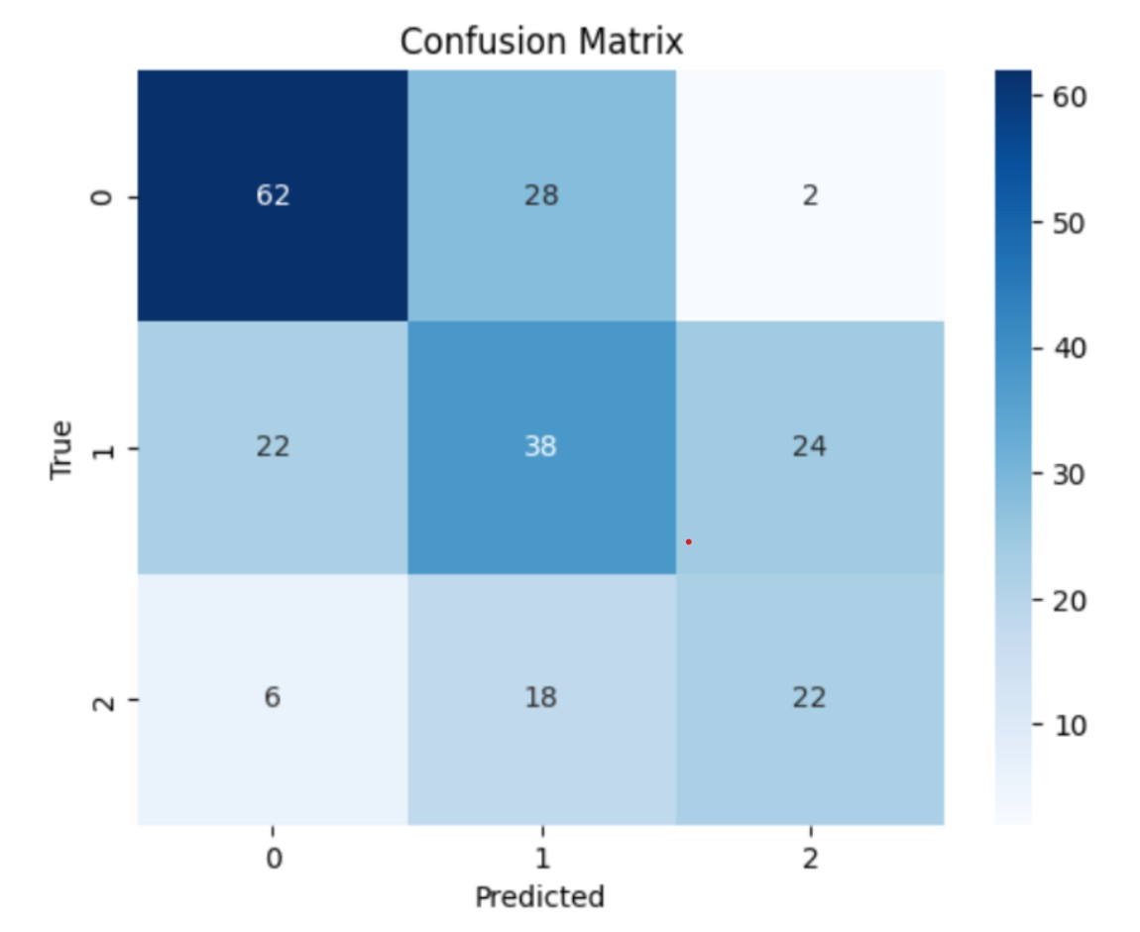
Fig. 6. Confusion matrix of custom model.
the precision and recall were 0.78 and 0.76, respectively. The MCI class, which is inherently more ambiguous and clinically challenging, yielded slightly lower metrics, with a precision of 0.68 and recall of 0.70. The overall macroaveraged F1-score across the three classes was 0.77. To complement the numerical results, the confusion matrix in Fig. 1 provides a visual representation of classification outcomes. It highlights the model’s ability to reliably identify healthy subjects and reveals specific patterns of misclassification, particularly between the MCI and AD categories. Together, Fig. 7 and Table 2 offer a comprehensive overview of the model’s classification performance, illustrating both its strengths and areas for further refinement.
IV. CONCLUSIONS
Early and accurate diagnosis of Alzheimer’s Disease (AD) is critical for timely intervention and effective disease management. In this study, we investigated the efficacy of deep learning approaches for classifying stages of dementia from EEG signals. The custom ResNet-18 model exhibited reliable performance, while the fine-tuned pretrained model demonstrated superior generalization, achieving a test accuracy of 76.81% and improved precision and recall scores—particularly in correctly identifying Healthy Controls. While the model performed strongly overall, there were notable misclassifications between Mild Cognitive Impairment (MCI) and
TABLE II
CLASSIFICATION REPORT OF FINE-TUNED MODEL
Class | Precision | Recall | F1-score | Support
HC | 0.85 | 0.85 | 0.85 | 46
MCI | 0.68 | 0.70 | 0.69 | 46
AD | 0.78 | 0.76 | 0.77 | 46
Accuracy |  |  | 0.77 | 138
Macro avg | 0.77 | 0.77 | 0.77 | 138
Weighted avg | 0.77 | 0.77 | 0.77 | 138
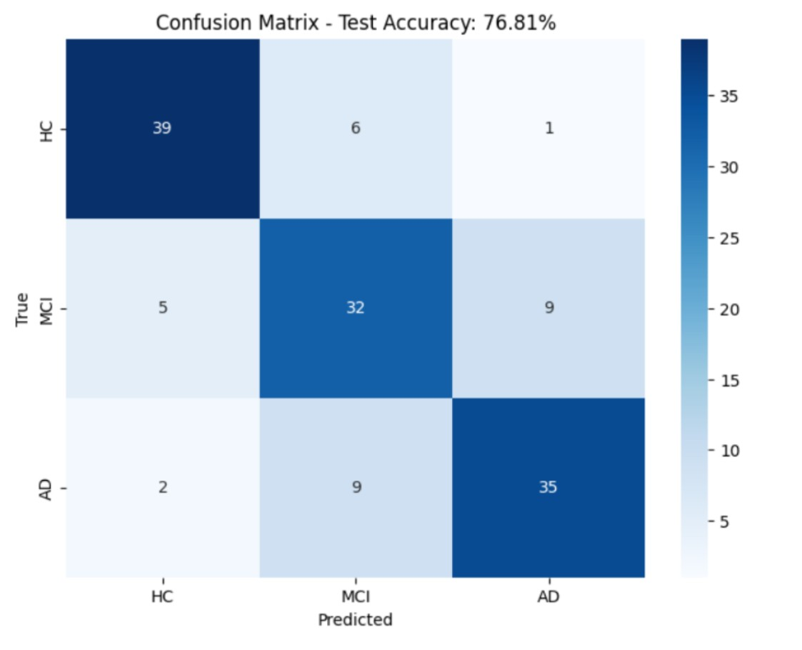
Fig. 7. Classification report of fine-tuned model
Alzheimer’s Disease—two clinically adjacent and often overlapping categories. To address this, future work could explore multimodal integration strategies, combining EEG with complementary data sources such as structural MRI, cognitive test scores, or genetic biomarkers. Additionally, incorporating attention mechanisms or temporal-aware modules (e.g., Transformers or TCNs) may further enhance the model’s sensitivity to subtle progression patterns between MCI and AD. To promote transparency and clinical trust, future work will incorporate Explainable AI (XAI) techniques such as saliency maps to highlight which EEG regions influenced model predictions. This can help clinicians interpret decisions, uncover relevant biomarkers, and support the safe use of deep learning in healthcare.
ACKNOWLEDGEMENTS
The authors gratefully acknowledge the invaluable guidance and support provided by the Center for Data Science and Applied Machine Learning (CDSAML), PES University, RR Campus. Their mentorship was instrumental in the successful execution of this project, offering crucial insights and resources that facilitated the development of the automated classification of Alzheimer’s Disease using EEG signals. This work was conducted as part of an internship at CDSAML from June to July 2025.
REFERENCES
- He, K., Zhang, X., Ren, S., & Sun, J. (2016). Deep residual learning for image recognition. In Proceedings of the IEEE conference on computer vision and pattern recognition (pp. 770-778).
- Alzheimer’s Disease and Dementia. What is Alzheimer’s? [Online]. Available: https://www.alz.org/alzheimers-dementia/what-is-alzheimers [Accessed: Nov. 21, 2023].
- B. Jiao et al., “Neural biomarker diagnosis and prediction to mild cognitive impairment and Alzheimer’s disease using EEG technology,” Alzheimer’s Res. Ther., pp. 1–14, 2023, doi: 10.1186/s13195-02301181-1.
- J. Hardy and D. J. Selkoe, “The amyloid hypothesis of Alzheimer’s disease: Progress and problems on the road to therapeutics,” Science, vol. 297, pp. 353–356, 2002. doi: 10.1126/science.1072994.
- A. H. Al-Nuaimi, M. Bluma, S. S. Al-Juboori, C. S. Eke, E. Jammeh,¨ L. Sun, and E. Ifeachor, “Robust EEG Based Biomarkers to Detect Alzheimer’s Disease,” Brain Sci., vol. 11, no. 8, p. 1026, 2021. [Online]. Available: https://doi.org/10.3390/brainsci11081026
- Centers for Disease Control and Prevention, National Center for Health Statistics. National Vital Statistics System, Mortality with U.S.-Mexico Border Regions 1999–2021 on CDC WONDER Online Database, released in 2021. Accessed at http://wonder.cdc.gov/ucd-border.html on Oct 4, 2023 6:40:44 PM..
- N. Houmani, F. Vialatte, E. Gallego-Jutgla, G. Dreyfus, V. H. Nguyen-` Michel, J. Mariani, and K. Kinugawa, “Diagnosis of Alzheimer’s disease with Electroencephalography in a differential framework,” PloS One, vol. 13, no. 3, p. e0193607, 2018. [Online]. Available:
https://doi.org/10.1371/journal.pone.0193607
- A. Tsolaki, D. Kazis, I. Kompatsiaris, V. Kosmidou, and M. Tsolaki, “Electroencephalogram and Alzheimer’s disease: Clinical and research approaches,” Int. J. Alzheimers. Dis., vol. 2014, 2014, doi: 10.1155/2014/349249.
- M. Kim, Y. C. Youn, and J. Paik, “Deep learning-based EEG analysis to classify normal, mild cognitive impairment, and dementia: Algorithms and dataset,” *NeuroImage*, vol. 272, p. 120054, 2023. doi: 10.1016/j.neuroimage.2023.120054.
- Smith, S. W. (1997). The Scientist and Engineer’s Guide to Digital Signal Processing or more specific EEG signal processing references such as Sornmo, L., Laguna, P. (2005). Bioelectrical Signal Processing¨ in Cardiac and Neurological Applications. Elsevier.
- Roy, Y., Banville, H., Albuquerque, I., Gramfort, A., Falk, T. H., Faubert, J. (2020). Deep learning-based electroencephalography analysis: a systematic review. Journal of Neural Engineering, 17(4), 041001.
- Kingma, D. P., Ba, J. (2015). Adam: A Method for Stochastic Optimisation. International Conference on Learning Representations (ICLR).
- Smith, L. N. (2017). Cyclical learning rates for training neural networks.
IEEE Winter Conference on Applications of Computer Vision (WACV).
- A. N. Mohammed, “Detecting cognitive decline in Alzheimer’s disease using brain signals: An EEG based classification approach,” in Proc. IEEE 4th Int. Maghreb Meeting Conf. Sci. Tech. Automat. Control Comput. Eng. (MI-STA), Tripoli, Libya, 2024, pp. 613–618, doi: 10.1109/MISTA61267.2024.10599651.
- D. Klepl, F. He, M. Wu, D. J. Blackburn, and P. Sarrigiannis, “Adaptive gated graph convolutional network for explainable diagnosis of Alzheimer’s disease using EEG data,” IEEE Trans. Neural Syst. Rehabil. Eng., vol. 31, pp. 3978–3987, 2023, doi: 10.1109/TNSRE.2023.3321634.
- M. S. Kamal, A. Northcote, L. Chowdhury, N. Dey, R. G. Crespo, and E. Herrera-Viedma, “Alzheimer’s patient analysis using image and gene expression data and explainable-AI to present associated genes,” IEEE Trans. Instrum. Meas., vol. 70, pp. 1–7, 2021, Art. no. 2513107, doi:
10.1109/TIM.2021.3107056.

